**Chapter 5**

**5. Coding**

**5.1 To create tables:**

CREATE TABLE MEMBERS

(

MID INT PRIMARY KEY,

MNAME VARCHAR2(255),

EMAIL VARCHAR2(255),

DOB DATE,

GENDER VARCHAR2(255),

ADDRESS VARCHAR2(255),

REG_DATE DATE

);

CREATE TABLE ACTIVITY

(

AID INT PRIMARY KEY,

JDATE DATE,

EVENT VARCHAR2(255)

);

CREATE TABLE PACKAGE

(

PID INT PRIMARY KEY,

DURATION VARCHAR(255),

CHARGE VARCHAR(255)

);

CREATE TABLE PAYMENT

(

PAYID INT PRIMARY KEY,

AMOUNT INT,

MID REFERENCES MEMBERS(MID),

PID REFERENCES PACKAGE(PID)

);

CREATE TABLE TRAINER

(

TID INT PRIMARY KEY,

TNAME VARCHAR(255),

AID REFERENCES ACTIVITY(AID)

);

**5.2 To insert tuples:**

INSERTING VALUES IN MEMBERS

insert into members values(1,'Subash','subashg@gmail.com','23-MAR-1998','M','BIRGUNJ NEPAL','12-AUG-2018');

insert into members values(2,'Spandan','spandann@gmail.com','10-aug-1998','M','Kathmandu NEPAL','13-AUG-2018');

insert into members values(3,'Bibek','bibekb@gmail.com','11-MAR-1998','M','Pokhara NEPAL','14-AUG-2018');

insert into members values(4,'Nabin','nabink@gmail.com','02-dec-1998','M','Bhairawa NEPAL','15-AUG-2018');

insert into members values(5,'Sujan','sujangh@gmail.com','05-jan-1998','M','Lalitpur NEPAL','16-AUG-2018');

insert into members values(6,'Reshma','reshma@gmail.com','11-dec-1997','F','Koteshwor Nepal','12-APR-2018');

insert into members values(7,'Mahima','mahima@gmail.com','17-dec-1997','F','Simara Nepal','19-JAN-2018');

INSERTING VALUES IN ACTIVITY

insert into activity values(1,'16-April-2018','ZumbaFitness');

insert into activity values(2,'17-April-2018','BodyBuilding');

insert into activity values(3,'18-April-2018','Yoga');

INSERING VALUES IN PACKAGE

insert into package values(1,'3 months','2500');

insert into package values(2,'6 months','4000');

insert into package values(3,'1 year','6000');

insert into package values(4,'2 years','9000');

INSERTING VALUES IN PAYMENT

insert into payment values(1,2500,1,1);

insert into payment values(2,9000,2,4);

insert into payment values(3,4000,3,2);

insert into payment values(4,6000,4,3);

insert into payment values(5,2500,5,1);

INSERTING VALUES IN TRAINER

insert into trainer values(1,'Rajesh',1);

insert into trainer values(2,'Hari',2);

insert into trainer values(3,'Suresh',3);

insert into trainer values(4,'Sakar',1);

insert into trainer values(5,'Sandeep',2);

insert into trainer values(6,'Avisek',3);

SELECT * FROM MEMBERS

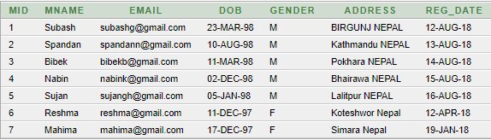

SELECT * FROM ACTIVITY

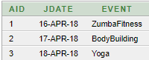  
  
  
SELECT * FROM PACKAGE  
  
  
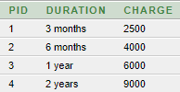

SELECT * FROM PAYMENT

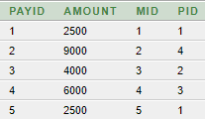

SELECT * FROM TRAINER

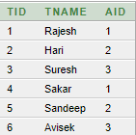

**5.3 Queries**

1. FIND THE NAME OF THE PERSON WHO IS FROM ‘Pokhara NEPAL’ ?

SELECT MNAME

FROM MEMBERS

WHERE ADDRESS='Pokhara NEPAL';



2. FIND THE MEMBERS WHO HAVE ENROLLED IN MORE THAN 1 PACKAGE WITH THEIR EMAIL AND DOB?

SELECT M.MID,M.MNAME,M.email,M.dob

FROM MEMBERS M,PAYMENT P1,PACKAGE P2

WHERE M.MID=P2.PID AND

P1.PID=P2.PID

GROUP BY M.MID,M.MNAME,M.email,M.dob

HAVING COUNT(*)>1;

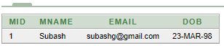

3. FIND THE AMOUNT PAID BY THE MEMBER NABIN?

SELECT P.AMOUNT

FROM PAYMENT P,MEMBERS M

WHERE P.MID=M.MID

AND MNAME='Nabin';



4. FIND THE NAME OF MEMBERS WHO HAVE PAID CHARGE MORE THAN 5000?

SELECT distinct M.MNAME

FROM MEMBERS M,PACKAGE P1,PAYMENT P2

WHERE M.MID=P2.MID AND

P2.PID=P1.PID AND

P1.CHARGE>5000

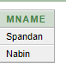

5.FIND THE NAME OF THE 'MALE' MEMBER WHO HAS REGISTERED FOR THE DURATION OF '6 MONTHS'?

SELECT M.MNAME

FROM MEMBERS m

WHERE GENDER='M' AND

m.MID IN (SELECT P1.PID

FROM PAYMENT P1,PACKAGE P2

WHERE P1.PID=P2.PID AND

DURATION='6 months');

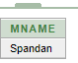

6. FIND THE NAME AND ACTIVITY ID OF THE TRAINER INVOLVED IN YOGA?

SELECT T.TNAME,T.AID

FROM TRAINER T,ACTIVITY A

WHERE T.AID=A.AID AND

A.EVENT='Yoga'

